PROJECT REPORT

# PLANTS VS ZOMBIES

COURSE: OPJECT ORIENTED PROGRAMMING INTERNATIONAL UNIVERSITY – VIETNAM NATIONAL UNIVERSITY HCM School of

Computer science and engineering

**Declaration**

We hereby declare the project report titled “PLANTS VS ZOMBIES” is submitted to Mr.Nghia . This report has been prepared on the basis of our own work where other published and unpublished source materials have been used, these have been acknowledged. This project work is submitted in partial fulfillment for School of Computer Science and Engineering, International University.

Group member:

|  |  |  |
| --- | --- | --- |
| Name | Student ID | Contribution |
| Nguyễn Đức Quốc Anh | ITITWE20018 | 33,33% |
| Lê Trọng Vinh | ITCSIU23045 | 33,33% |
| Nguyễn Phước Được | ITCSIU23005 | 33,33% |

# I.INTRODUCE TO THE GAME:

Plants vs Zombies was released on 5/5/2009 by the publisher Popcap. Designer George Fan and his collaborators have created a game about the battle between the undead and… trees. This is a really crazy idea. After more than 10 years, Plants vs Zombies has now become a classic game, it is impossible not to mention when talking about the development of the Tower Defense series.

Plants vs. Zombies is a tower defense video game developed and published by PopCap Games. The game was originally released for Windows and Mac OS X platforms, then ported to consoles, handhelds, and mobile devices. In Plants vs. Zombies, players will take on the role of a host in the midst of a zombie

apocalypse. When a horde of zombies begins to attempt to approach the house along parallel lanes, the player must protect the house by planting trees in the lane to shoot bullets that kill the zombies or harm them. The player collects a currency called "sun" to buy plants. If a zombie reaches the house by any lane, the level is considered failed, and the player will have to restart the level there.

Game interface overview: Example:

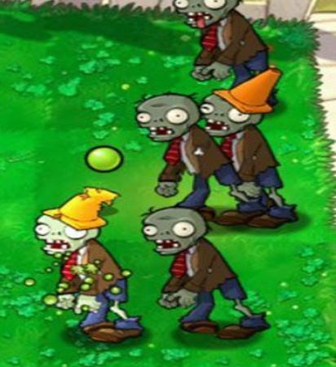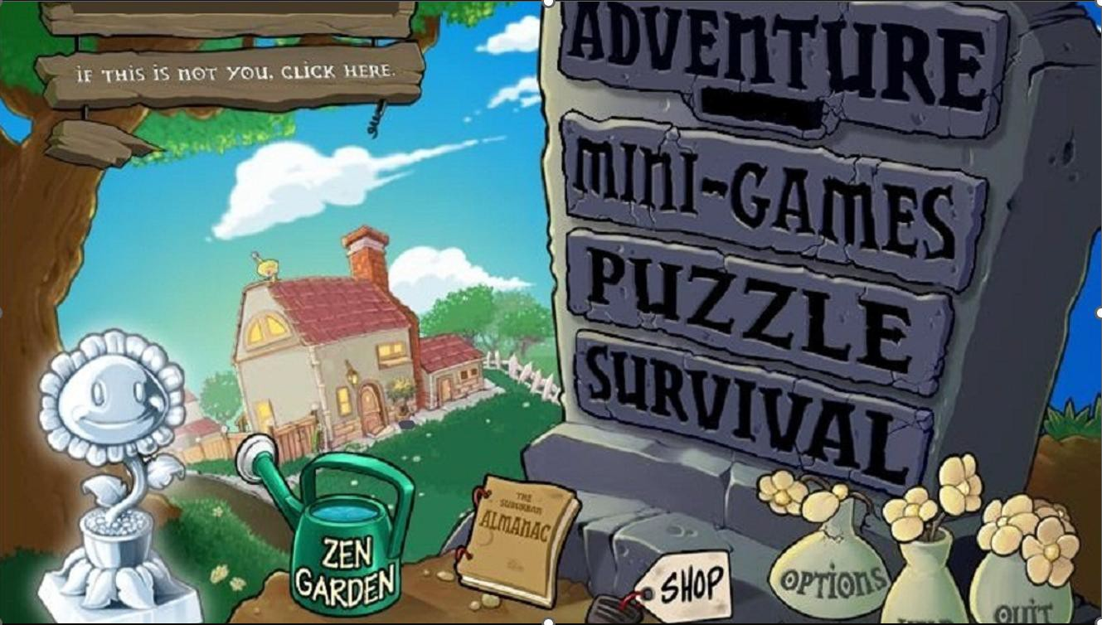

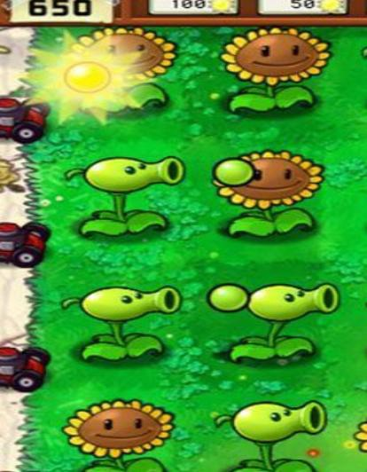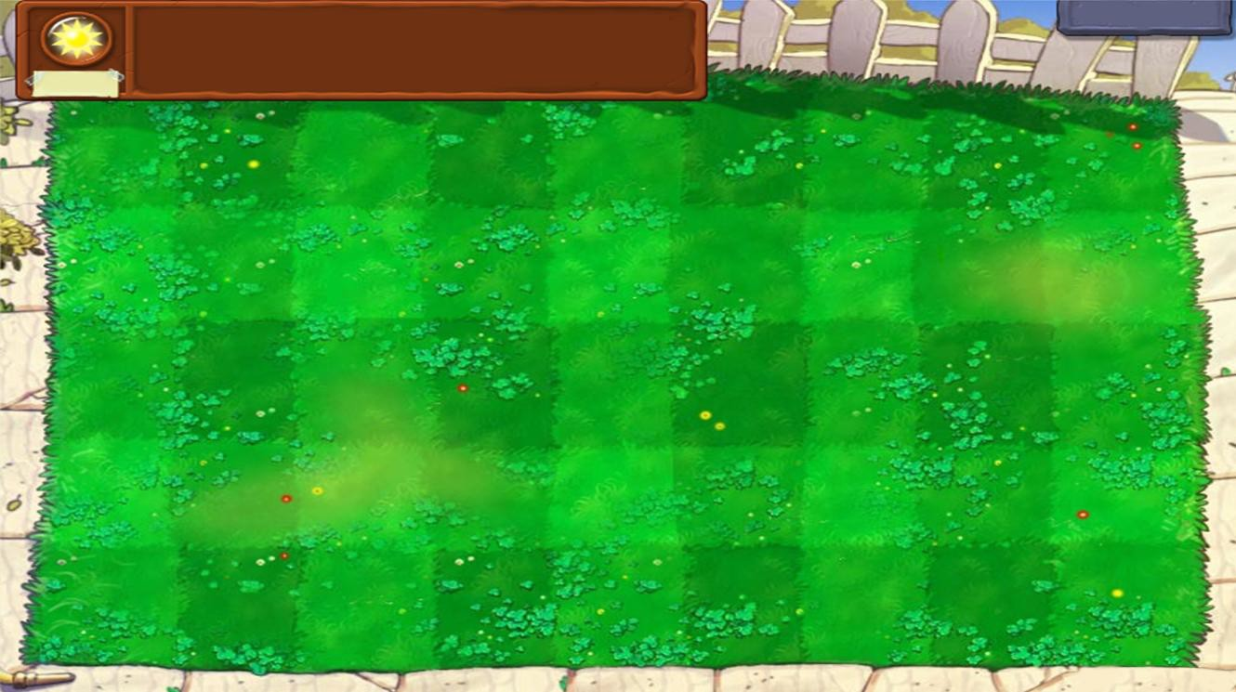

## Items:

These are the items what we used in the game interface:



* + - Plant:
    - 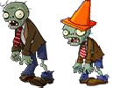Zombie

## 2.2 How to play:

* + - At the beginning of each level, players should try to develop themselves a lot of Sunflowers to be able to face the sun and earn money to buy weapons:

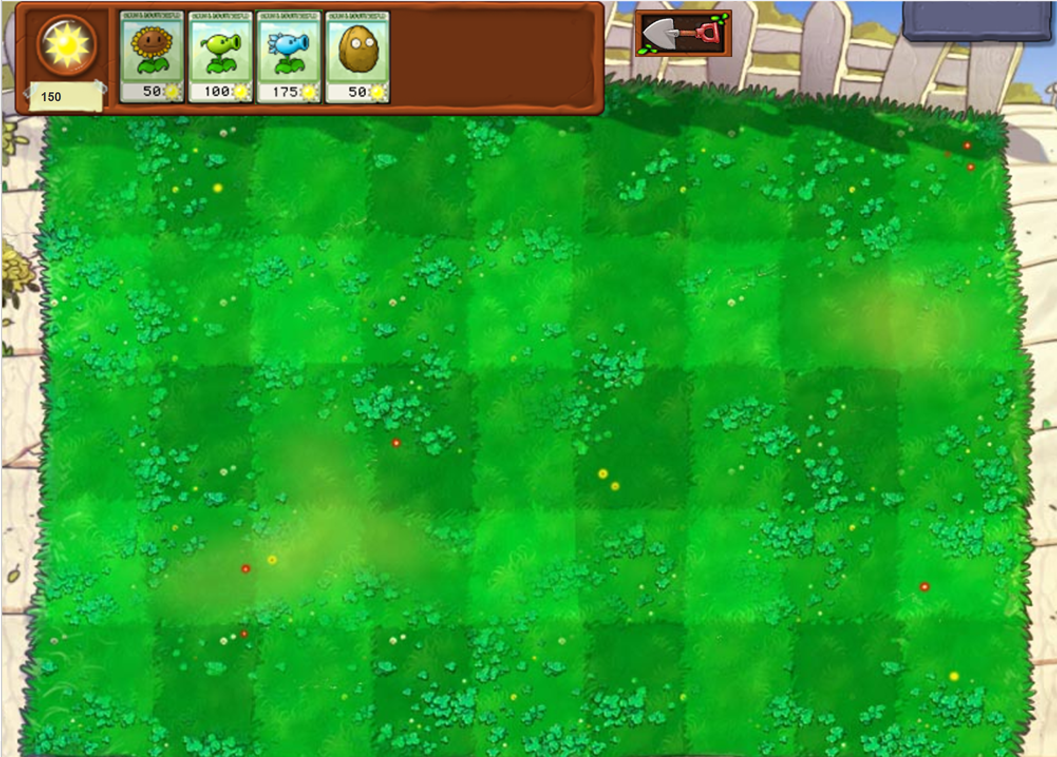

* + - Every 5s a sun will drop randomly at the top of the game and every 15s a sun will spawn from the sunflower. From there players will use sun to buy peashooter to quickly kill zombies:
    - 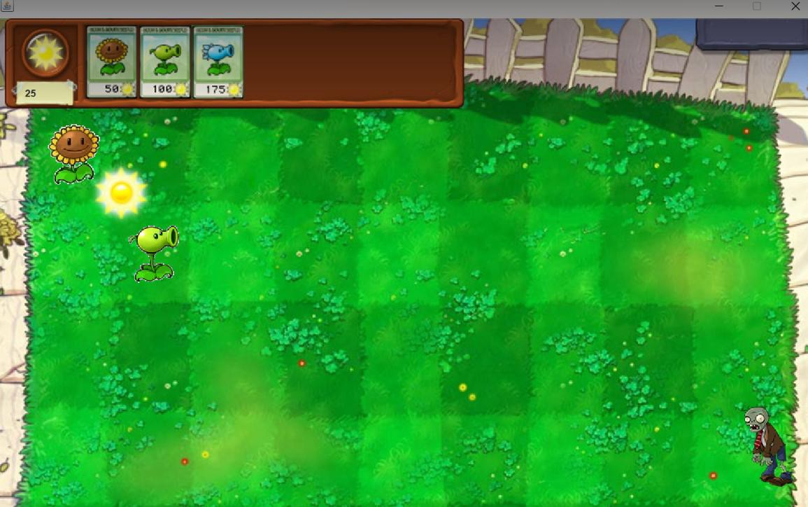
    - Because later, the difficulty will increase because there is a new stronger and stronger zombie, so we need to continue to accumulate sun to buy a new
    - items

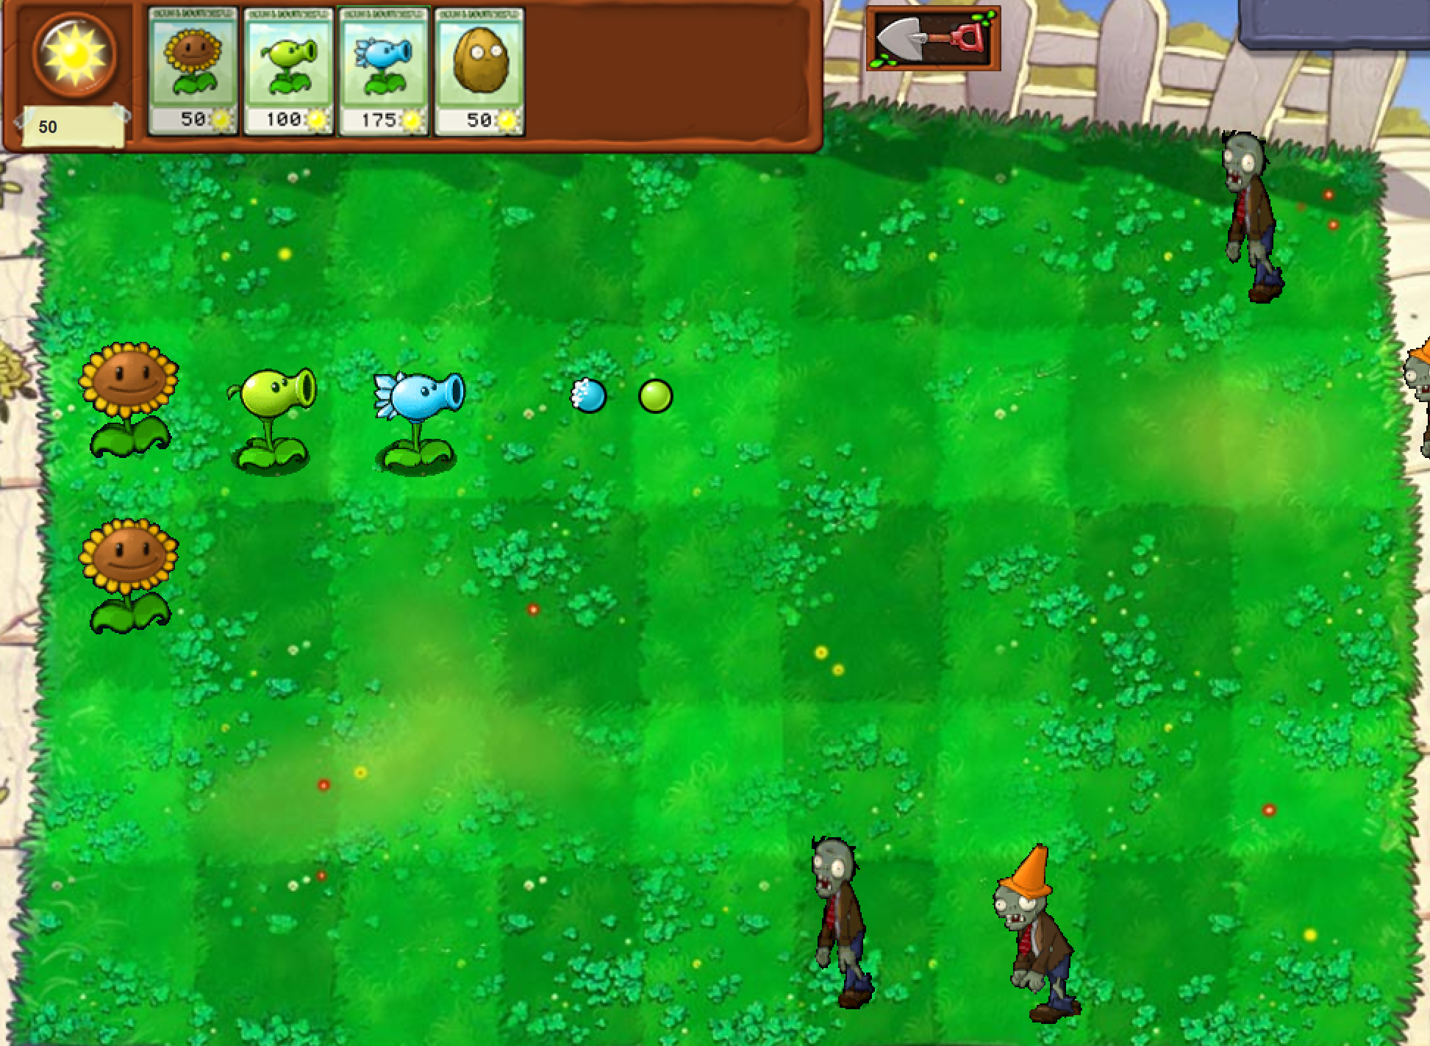

# II.PROJECT ANALYSIS:

1. UML

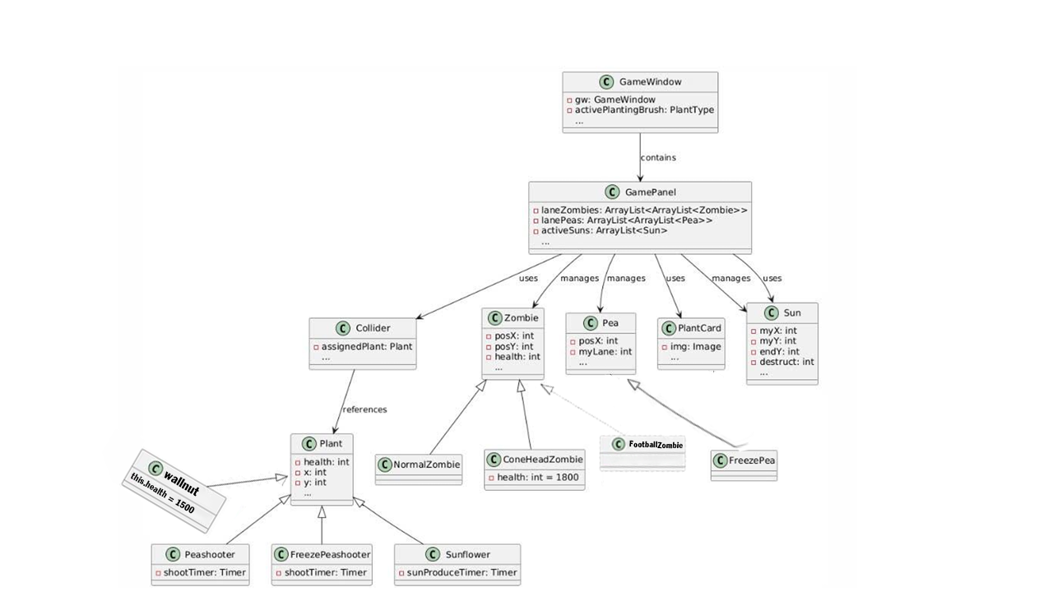

2. Use case diagram



## GameWindow:

The GameWindow class serves as the main entry point and GUI container for the game. It initializes and displays the game environment, providing players with the interface to interact with the game. Here's a step-by-step explanation of how GameWindow works:

### **1. Entry Point:**

* The main method runs the program by creating an instance of GameWindow with a boolean argument (true).
* The GameWindow(boolean b) constructor is called:
  + If b is true, it displays a Menu (not detailed in the code, but likely the start screen).
  + The player can start the game from this menu.

### **2. Game Initialization:**

* When the game begins, GameWindow.begin() is called:
  + It disposes of the current GameWindow instance (closing the menu or previous game session).
  + A new instance of GameWindow() (no arguments) is created to initialize the gameplay.

### **3. Main Gameplay Window (**GameWindow() **Constructor):**

This constructor sets up the entire game interface:

#### **a. Window Configuration:**

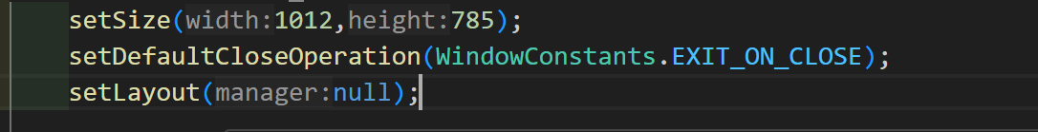

* Sets the size (1012x785) and disables resizing.
* Uses a layered pane (JLayeredPane) to manage overlapping components like the game panel, UI elements, and plant selection cards.

#### **b. Adding the Game Panel:**

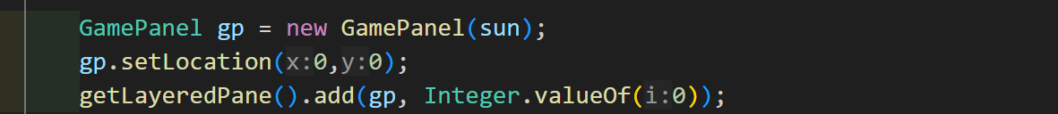

* Creates a GamePanel instance (gp), which is the core gameplay area.
* Links the game's sun scoreboard to a JLabel that displays the player's current sun points.
* Adds GamePanel to the lowest layer (Integer.valueOf(0)) of the JLayeredPane.

#### **c. Adding Plant Selection Cards:**

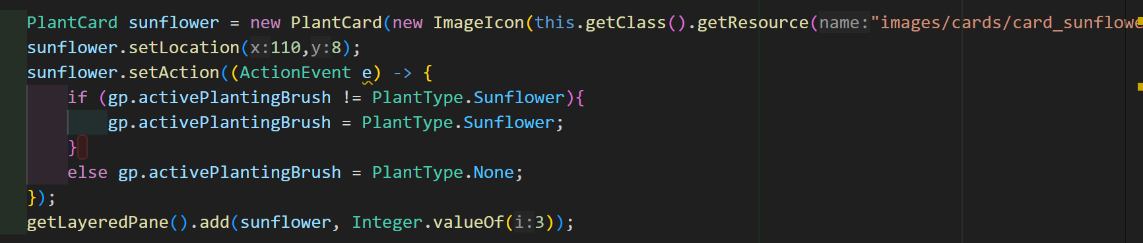

* Adds PlantCard components for each plant type (e.g., Sunflower, Peashooter) and the shovel tool.
* Configures each PlantCard with an image and an action:
  + Clicking a card sets the GamePanel's activePlantingBrush to the selected plant type.
  + Clicking the same card again deselects it by setting activePlantingBrush to None.

### **4. Game Loop and Interaction:**

Once the GameWindow is fully initialized, the game loop is handled by the GamePanel:

* **Timers:** Regularly update the game's state (e.g., plant growth, zombie movement, and sun production).
* **Mouse Movement:** Tracks the mouse for planting or tool usage.
* **Action Listeners:** Handles planting, removing plants, or selecting cards.
* **Graphics Rendering:** The paintComponent method in GamePanel redraws the game field and dynamically updates visuals like plants, zombies, and projectile

The LevelData class is a utility that manages the game's level data, handling both reading and writing the level information from and to a file named Level.txt. Below is a breakdown of its functionality and how it integrates with the rest of your game logic:

### Key Components:

1. **Static Variables**:



* + **Lvl**: Represents the current level as a string.
  + **Level**: A 2D array defining the types of zombies available for each level.
  + **LevelValue**: A 3D array defining the probability ranges for spawning each zombie type in the respective levels.

1. **Constructor (LevelData())**:

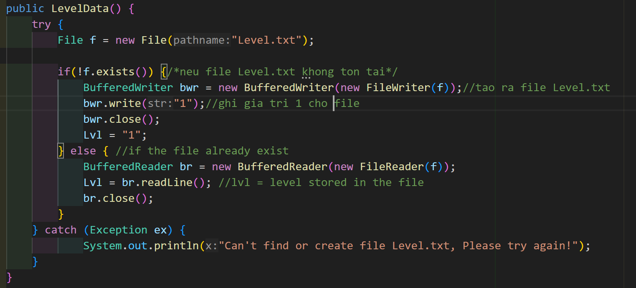

* + **Purpose**: Initializes the current level from Level.txt or creates this file if it doesn't exist.
  + **Flow**:
    - Checks if Level.txt exists:
      * If not: Creates the file and sets the initial level to "1".
      * If yes: Reads the level from the file and assigns it to Lvl.

1. **write Method**:

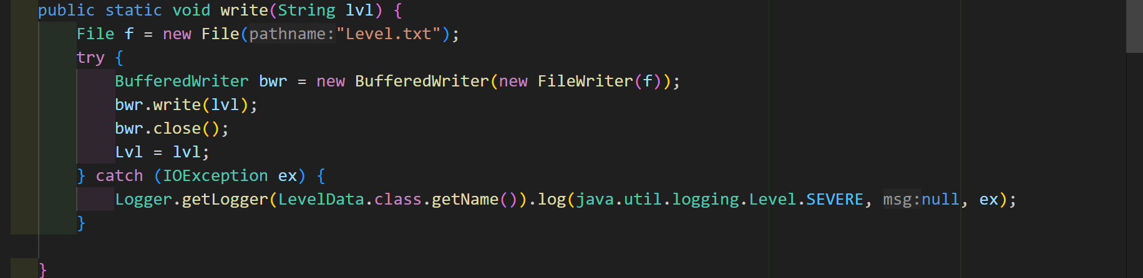

* + **Purpose**: Updates the level in Level.txt and synchronizes the Lvl variable.
  + **Usage**: Called when progressing to the next level or resetting the game to the first level.

1. **Integration with GamePanel**:
   * The Lvl variable is accessed in GamePanel when determining the zombie types (Level) and their probability ranges (LevelValue) for the current level.
   * When a level is completed (setProgress in GamePanel), this class updates Level.txt to reflect the new level or resets the data if all levels are completed.

### Example Usage:

#### **File Handling**:

* If Level.txt is missing, the constructor creates it with the initial level set to "1".
* The file's content controls the level progression, ensuring the game resumes from the last saved level.

#### **Zombie Spawning**:

* The game logic in GamePanel fetches:
  + Zombie types for the current level: Level[Integer.parseInt(Lvl)-1].
  + Spawn probability ranges: LevelValue[Integer.parseInt(Lvl)-1].

#### **Level Progression**:

* Upon completing a level:
  + If the current level is "1", it writes "2" to Level.txt and prepares the game for the second level.

If the second level is completed, it resets the game to the first level and terminates with a completion message **Game objects and their function**

The game is about detecting interactions between **Zombies**, **Plants**, and **Peas**. Here’s a breakdown:

**1. How plants and zombies interact with each other?**

The Collider class represents an invisible interactive zone on the game grid where plants can be placed and removed. It works by providing event-driven interactions and managing its assigned plant. Here’s a detailed explanation of how it works:

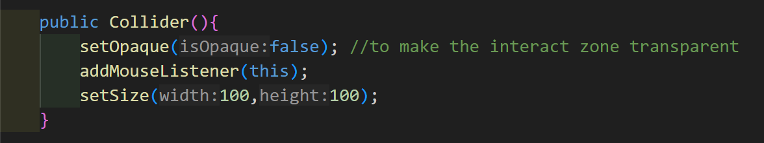

• **Interactive Zones**: Each Collider represents one cell (or tile) on the game grid, allowing player interactions such as planting or removing a plant.

• **Transparent Layer**: Colliders are invisible (setOpaque(false)), so they don't affect the game display.

**Core Responsibilities**

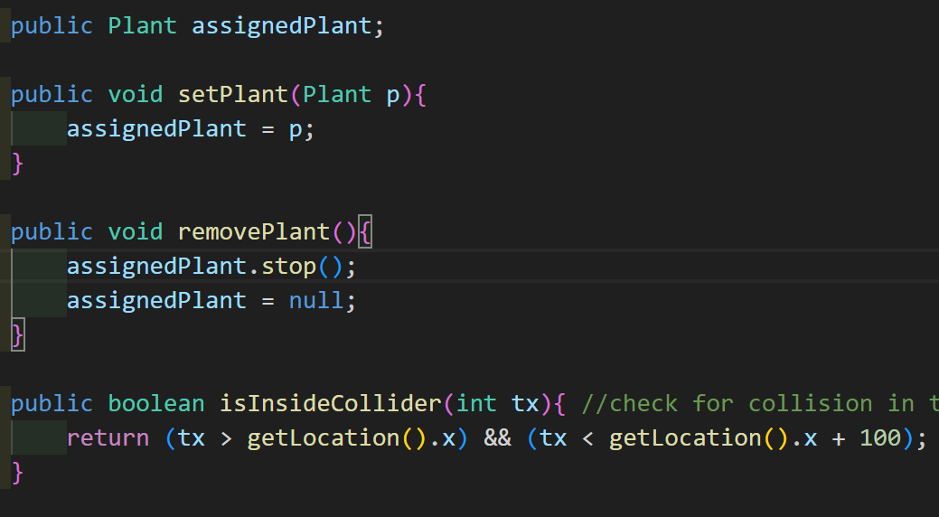

1. **Managing Plants**:
   * Each Collider can have one assigned plant, stored in the assignedPlant property.
   * Plants can be added or removed using:
     + setPlant(Plant p): Assigns a plant to the collider.
     + removePlant(): Stops and removes the plant from the collider.
2. **Handling User Actions**:
   * A Collider listens for mouse events via MouseListener. When clicked, it triggers its associated action (ActionListener), enabling the game to perform specific actions like planting or removing plants.
3. **Collision Detection**:
   * The isInsideCollider(int tx) method checks if a given x coordinate (tx) falls within the horizontal bounds of the collider.

**2. How plants works?**

* + The Plant class is an **abstract class** that acts as a blueprint for all plant types in the game. It contains.

information of all plant types like health point and position. Here is how it works:

**Key Components of the Plant Class**

1. **health Field:**
   * Stands for the plant's health. The default is set to 200, that means for normal plant type like PeaShooter or FreezePeaShooter, its hp is 200.
   * When a zombie attacks a plant, the plant's health will likely decrease. Once health reaches 0, the plant will be removed from the game.
2. **x and y Fields:**
   * These fields define position of the plant on the game field. It will define where the plant will be placed.
   * Based on loop in the gamePanel class, there are 45 blanks and every blank has it position in the x and y coordition. More over, each blank has a PlantActionListener() to interact with the user. So, the every plant has to have its specific postion
3. **gp Field:**
   * A reference to the GamePanel instance (gp) that owns this plant.
   * This allows the plant to interact with and access properties or methods in the GamePanel, such as the sunScore or laneZombies.
4. **Constructor (Plant(GamePanel parent, int x, int y)):**
   * Initializes the plant object.
     + **parent:** A reference to the GamePanel that contains this plant.
     + **x and y:** The grid position where the plant is placed.
5. **stop() Method:**
   * A placeholder method (empty implementation) intended to be overridden by subclasses of Plant.
   * Represents any cleanup or stopping actions specific to the plant type when it is removed or deactivated.
6. **abstract Modifier:**
   * This class cannot be instantiated directly. It serves as a base class for other specific types of plants (e.g., Peashooter, Sunflower, Wallnut).

**How the Plant Class is Used**

1. **Subclassing:**
   * Each specific plant type (e.g., Peashooter, Sunflower,FreezePeaShooter) extends the Plant class.
   * These subclasses inherit the fields and methods of the Plant class and can add specific behavior, such as:
     + Shooting projectiles (for Peashooter).
     + Generating suns (for Sunflower).
     + Blocking zombies with high health (for Wallnut).
2. **Game Panel Integration:**
   * A Plant object is assigned to a specific Collider in the GamePanel's grid layout.
   * Example: When a player plants a Peashooter, an instance of Peashooter is created and linked to a specific Collider.
3. **Game Logic:**
   * During gameplay, the game interacts with all plants through the Plant reference.
     + This ensures consistent access to shared properties (health, x, y) and polymorphic behavior (calling overridden methods like shoot() or generateSun()).
4. **Extensibility:**
   * New plant types can be created easily by extending the Plant class and overriding or adding behavior.

**3. How the PeaShooter (a Subclass of Plant) works**

The Peashooter class is a implementation of the Plant class and represents one of the fundamental plant types in the game. Its primary function is to shoot peas at regular intervals to attack zombies in its lane. Here’s how this class interacts with the game:

**Key Components**

**1. Class Definition**

* Extends the Plant class, inheriting the basic attributes like health, x, y, and the stop() method.
* Adds specific behavior to shoot projectiles (Peas) at zombies in its lane.

**2. Constructor**

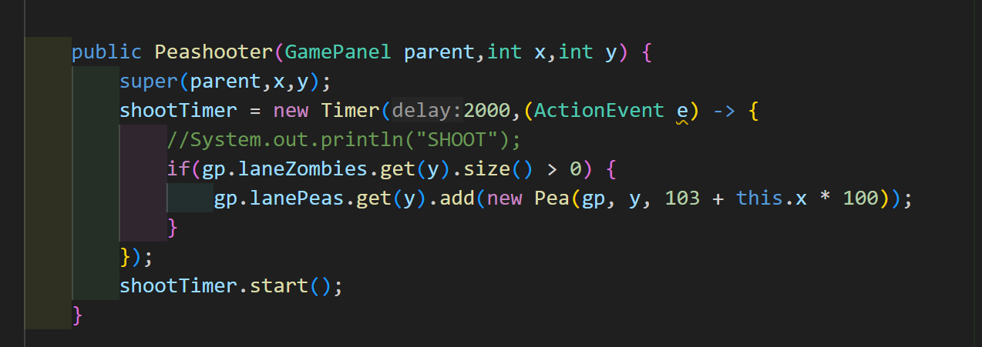

* **Parameters:**
  + parent: The GamePanel instance, representing the overall game state.
  + x: Horizontal position of the Peashooter.
  + y: Lane where the Peashooter is placed.
* **Behavior:**
  + Initializes a Timer (shootTimer) that triggers every 2000 milliseconds (2 seconds). That mean the PeaShooter will shoot every 2000ms.
  + The Timer checks if there are zombies in the same lane (gp.laneZombies.get(y)).
  + If zombies are present, it creates a new Pea object and adds it to the lane's pea list (gp.lanePeas.get(y)).
    - new Pea(gp, y, 103 + this.x * 100):
      * gp: Reference to the GamePanel.
      * y: Lane where the pea will move.
      * 103 + this.x * 100: Initial horizontal position of the pea, based on the Peashooter's x coordinate.

**3. stop() Method**

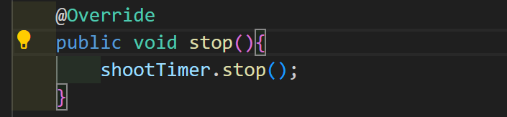

* Stops the shootTimer when the Peashooter is removed from the game or the game ends.
* Prevents further pea generation after the Peashooter is no longer active to prevent the errors.

**How Pea(the bullet of PeaShooter) work?**

The Pea class represents a projectile fired by plants (like the Peashooter) to damage zombies in its lane. Here's a concise explanation:

**Key Components**

1. **Attributes**:
   * posX: Horizontal position of the pea.
   * gp: Reference to the GamePanel (game state manager).
   * myLane: The lane where the pea is moving.
2. **Constructor**:

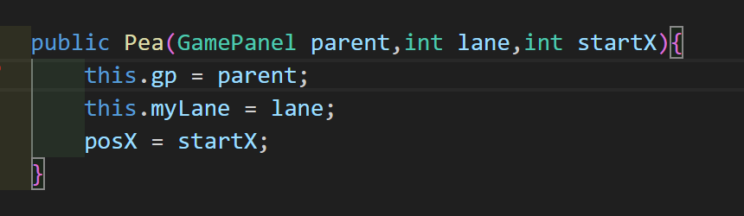

* + Initializes the pea's position (posX), lane (myLane), and game reference (gp).

1. **advance() Method**:

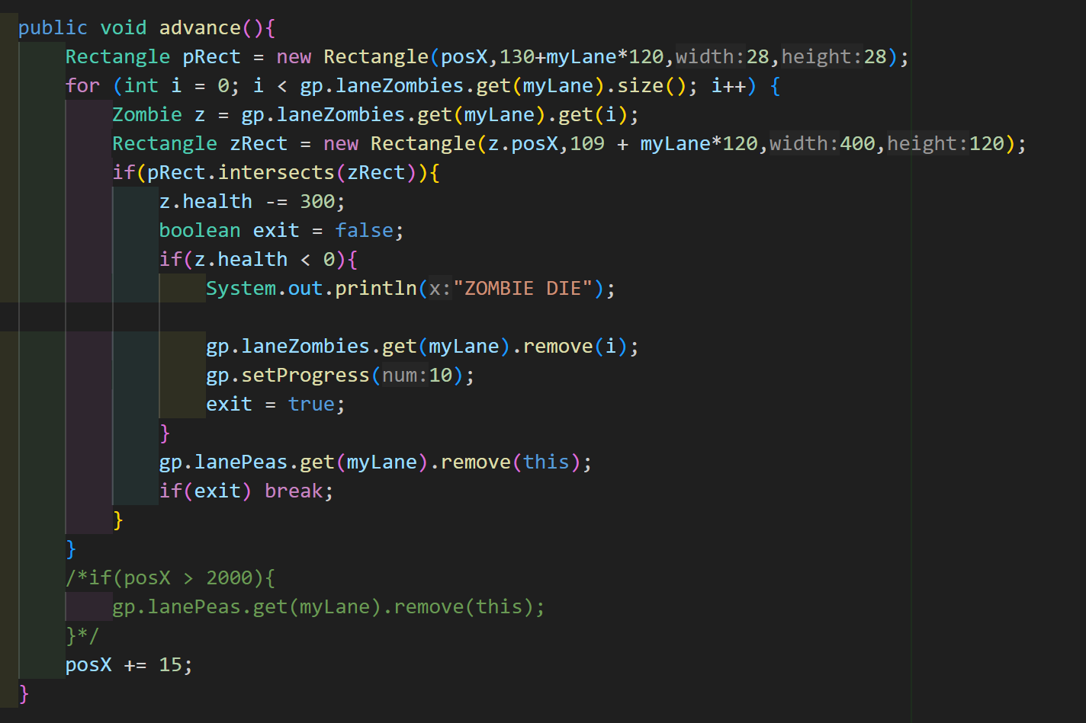

* + Moves the pea forward (posX += 15) everytime the advancerTimer loop in the GamePanel call it.
  + Detects collisions with zombies:
    - If a collision occurs:
      * Deals 300 damage to the zombie.
      * Removes the zombie if its health drops below 0.
      * Removes the pea after the collision.

**How the FreezePeaShooter works?**

The FreezePeashooter class is a subclass of the Plant class that extends its functionality to shoot **FreezePeas** instead of regular peas. It behaves similarly to the Peashooter class but introduces the additional mechanic of **slowing down zombies** in the FreezePea class. Here's a detailed breakdown of how this class interacts within the game:

**Key Components**

**1. Class Definition**

* Extends the Plant class, inheriting attributes like health, x, y, and gp.
* Shoots special projectiles (FreezePea) that not only damage zombies but also slow them.

**2. Constructor**

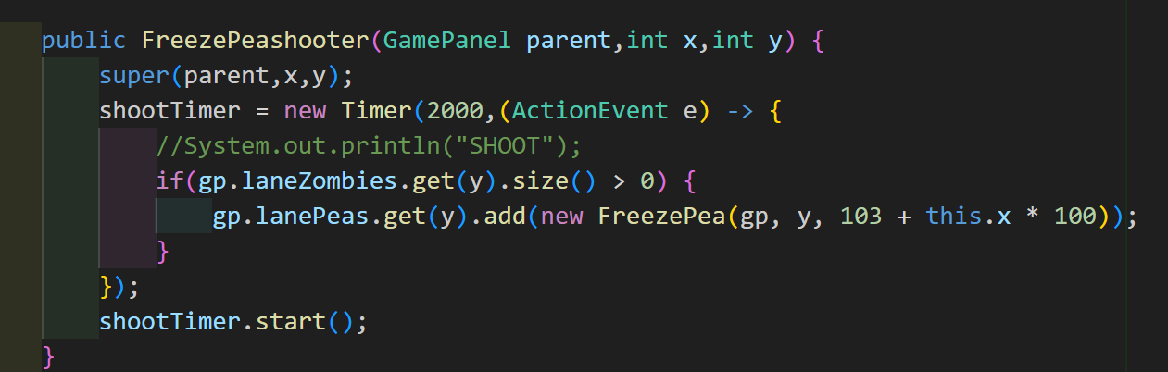

* **Parameters:**
  + parent: The GamePanel instance representing the game state.
  + x: The horizontal position of the FreezePeashooter.
  + y: The lane (vertical position) where it is placed.
* **Behavior:**
  + Initializes a Timer (shootTimer) that fires every 2000 milliseconds (2 seconds).
  + The timer checks if there are zombies in the same lane (gp.laneZombies.get(y)).
  + If zombies are present, a FreezePea is created and added to the lane's pea list (gp.lanePeas.get(y)).

**3. Freeze Pea Generation**

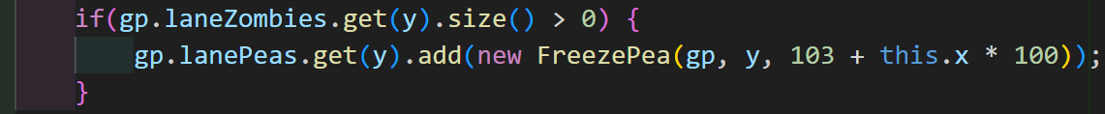

* **Creates a new FreezePea:**
  + gp: Reference to the GamePanel.
  + y: Lane where the FreezePea is fired.
  + 103 + this.x * 100: Starting horizontal position, calculated based on the FreezePeashooter's x coordinate.
* This projectile moves forward in the lane and interacts with zombies, as defined in the FreezePea class.

**4. stop() Method**

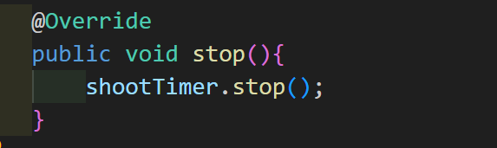

* Stops the shootTimer when the FreezePeashooter is removed from the game (e.g., destroyed or replaced).
* Prevents further FreezePea generation once the plant is inactive.

**How FreezePea(a subclass of Pea) work?**

The **FreezePea** is a specialized projectile in your game, designed to damage and slow down zombies it collides with. Its functionality is tightly integrated with the other classes you've shared, including the FreezePeashooter, GamePanel, and Zombie classes.

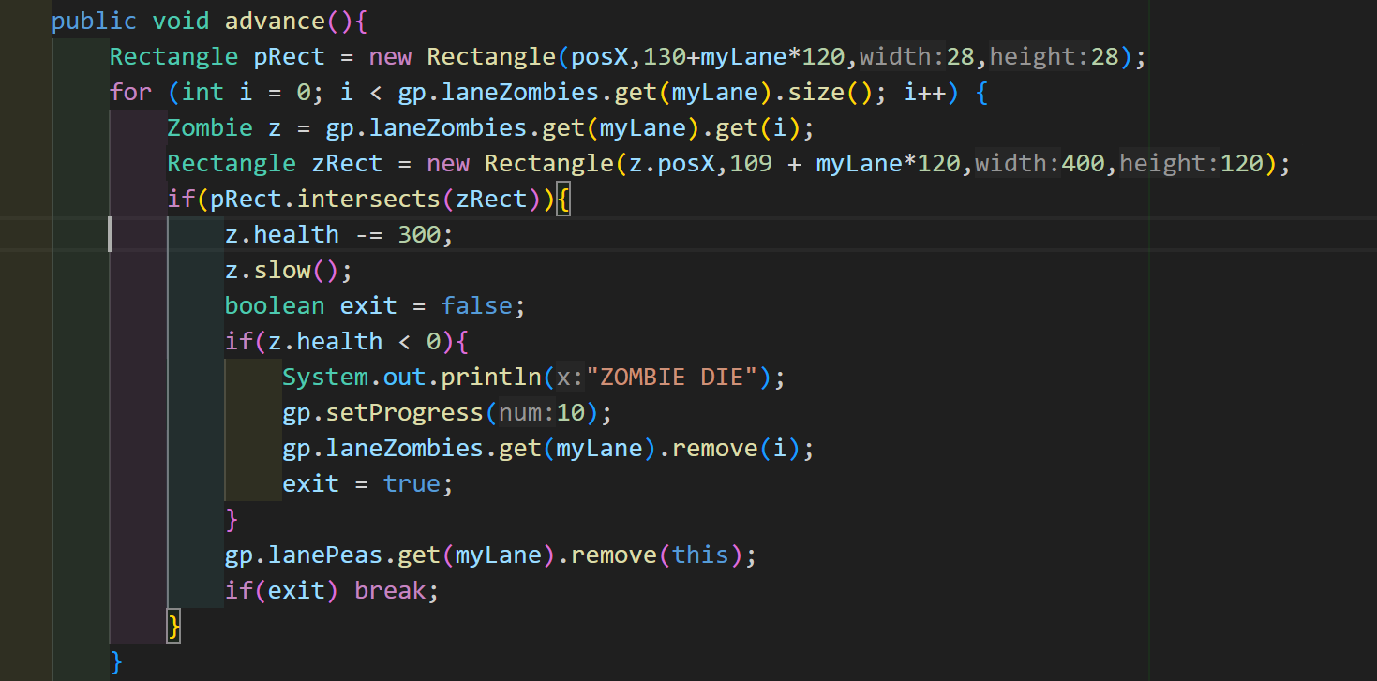

**FreezePea's Behavior**

**1. Creation**

* **Trigger**: A FreezePea is created every 2 seconds by the FreezePeashooter, but only if there are zombies in its lane.
* **Constructor Call**:

java

Sao chép mã

gp.lanePeas.get(y).add(new FreezePea(gp, y, 103 + this.x * 100));

* + y is the lane index where the shooter is located.
  + 103 + this.x * 100 places the FreezePea at the correct horizontal position, aligned with the shooter.

**2. Advancing (Moving Across the Lane)**

The advance() method moves the FreezePea and checks for collisions with zombies.

**How It Works Step-by-Step**

1. **Collision Detection**:
   * The advance() method uses a Rectangle (pRect) to represent the FreezePea's position and size.
   * Similarly, each zombie in the lane is represented by a Rectangle (zRect).
   * If pRect intersects with zRect, it means the FreezePea has hit a zombie.
2. **Applying Effects**:
   * When a collision is detected:
     + The zombie's health is reduced by **300**.
     + The slow() method is called on the zombie to reduce its movement speed.
3. **Handling Zombie Death**:
   * If the zombie’s health drops below 0:
     + A "ZOMBIE DIE" message is printed.
     + The zombie is removed from the lane's zombie list (gp.laneZombies.get(myLane)).
     + Game progress is incremented by **10** points (gp.setProgress(10)).
4. **Removing the FreezePea**:
   * After colliding with a zombie, the FreezePea is removed from the lane's pea list (gp.lanePeas.get(myLane)).
5. **Continuing Movement**:
   * If no collision occurs, the FreezePea moves forward by **15 pixels** (posX += 15).

**How Zombie class works?**

**1. Zombie Class (Base Class)**

The Zombie class defines the general behavior and characteristics of all zombies in the game. Here's a detailed breakdown of its components:

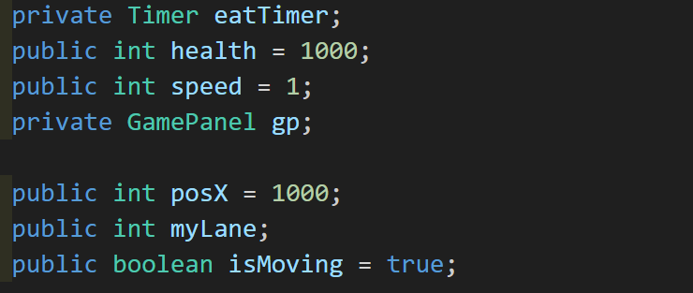

**Attributes:**

* **health**: The health of the zombie. Default is 1000, but subclasses can change this value.
* **speed**: The speed of the zombie. Default is 1, but subclasses can change this value (e.g., FootballZombie has a speed of 2).
* **posX**: The horizontal position of the zombie on the game field. This moves leftward as the zombie advances.
* **myLane**: The lane in which the zombie is located (there are multiple lanes, each with a set of colliders and plants).
* **isMoving**: A flag to check whether the zombie is moving. It’s set to true when the zombie is still advancing and false if it has reached the end (or eaten the player's brain).
* **eatTimer**: A Timer that manages the eating process. This timer is responsible for periodically reducing the health of plants when the zombie collides with them.

**Methods:**

* **advance()**:

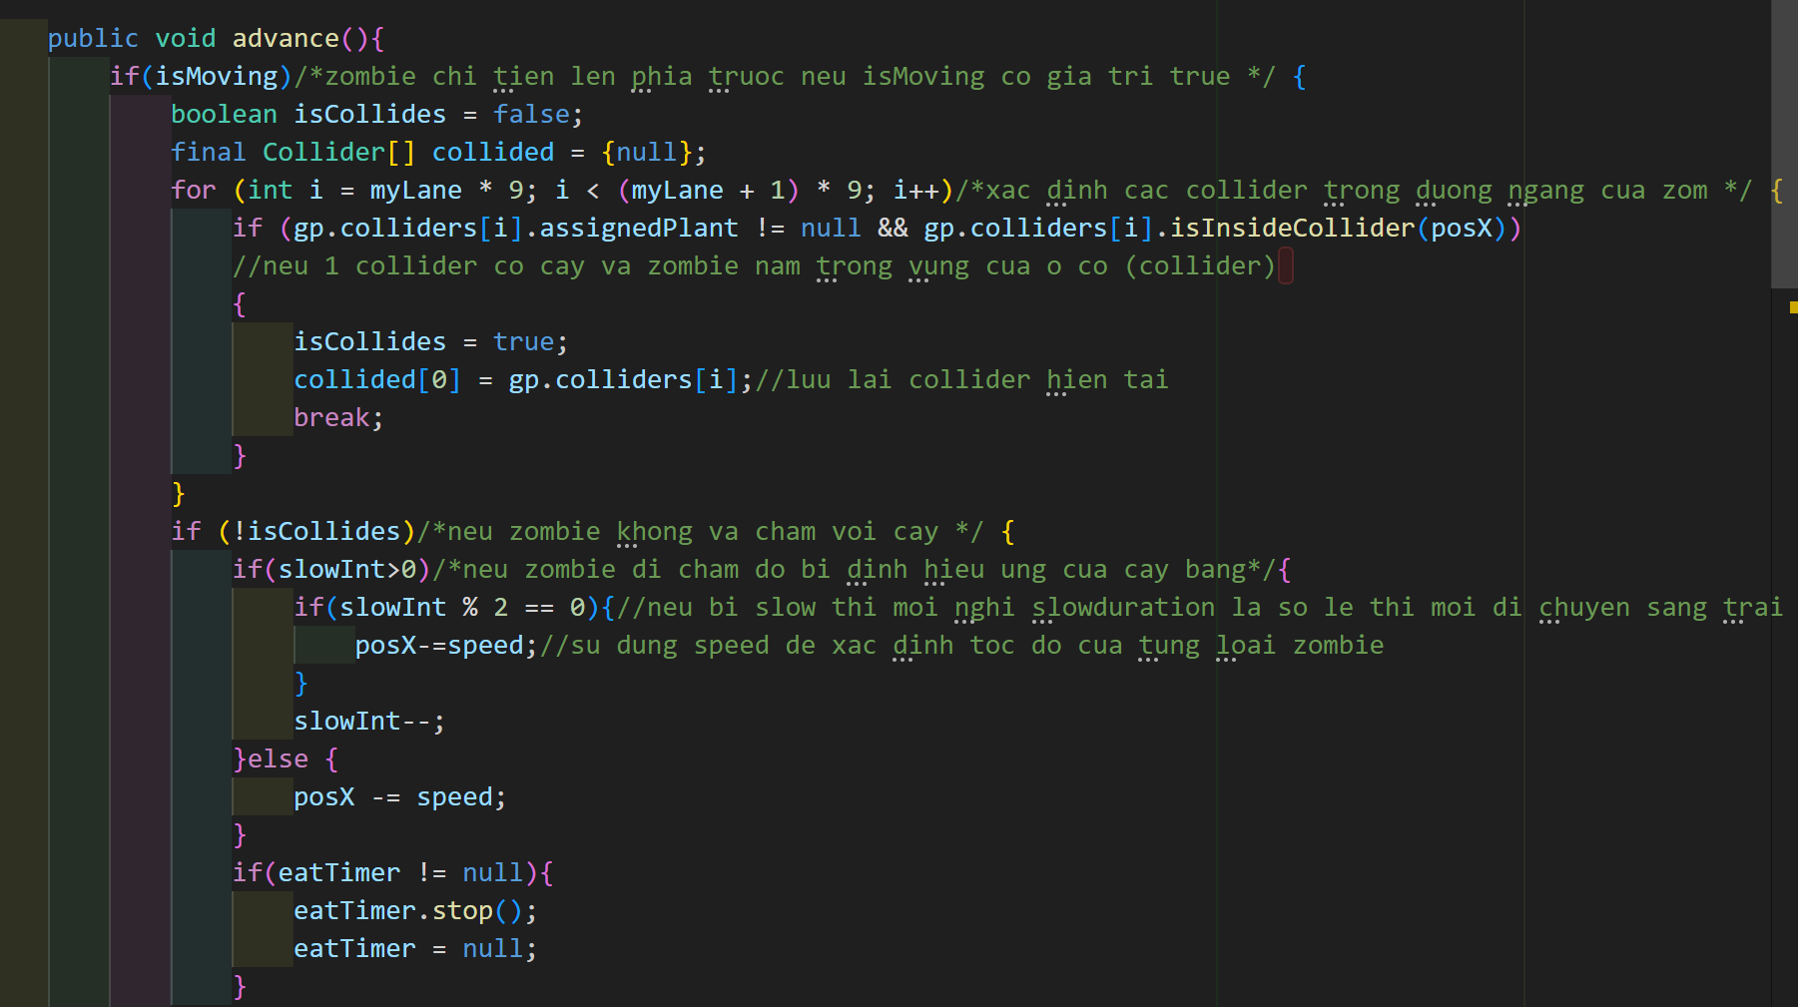

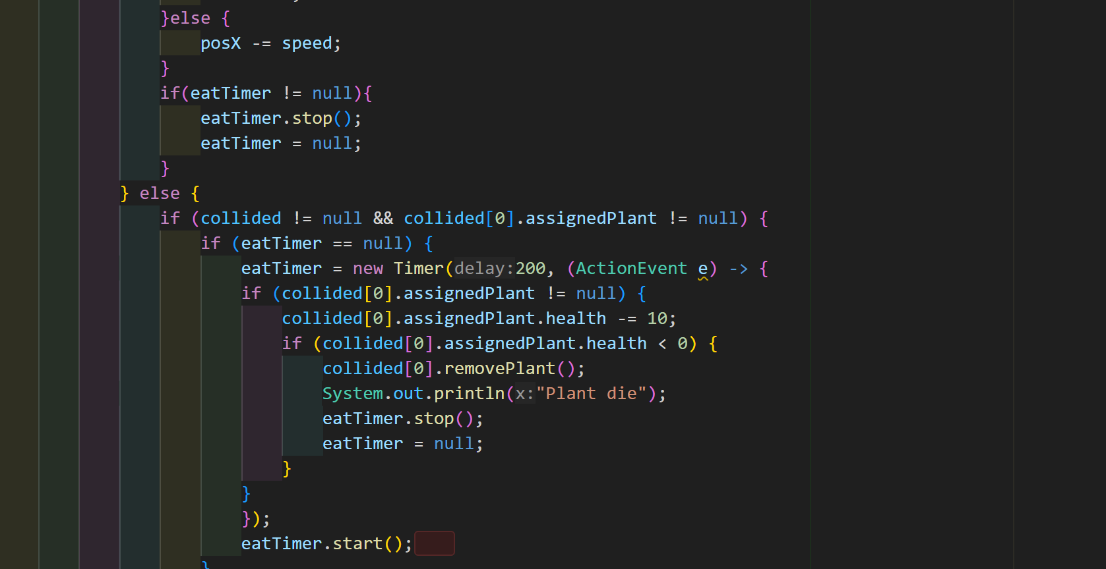

* + This method controls the zombie's movement.
  + First, it checks whether the zombie is currently allowed to move by verifying the isMoving flag.
  + If isMoving is true, it checks for collisions with plants in its lane (using the Collider objects).
  + If no collision is detected, the zombie moves leftward by its speed (posX -= speed).
  + If a collision is detected (with a plant), the zombie stops and starts eating the plant. This is handled by the eatTimer, which reduces the plant's health.

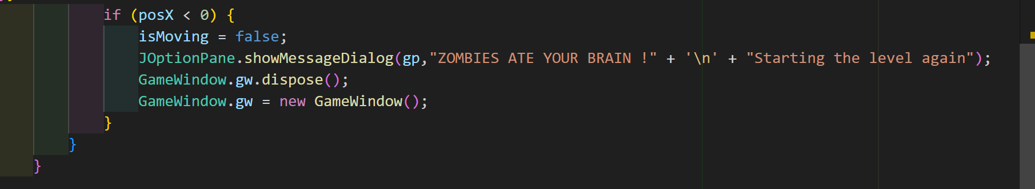

* + The zombie checks whether its health reaches 0 or if it reaches the left edge (posX < 0), at which point it either dies or ends the game.
* 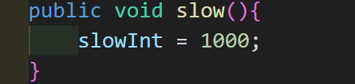**slow()**:
  + This method is called when a zombie is slowed (typically by a plant like FreezePea). It sets the slowInt variable to 1000, indicating that the zombie is in a slowed state.
  + The advance() method checks this variable and adjusts the zombie’s movement speed accordingly.

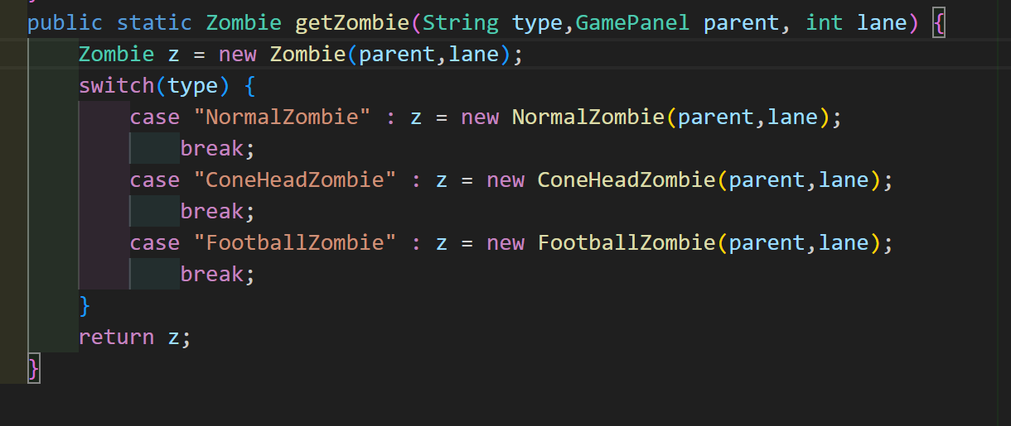

* **getZombie()**:
  + A static factory method that creates different types of zombies based on the type string passed to it. It creates and returns instances of the various zombie subclasses (e.g., NormalZombie, ConeHeadZombie, or FootballZombie).

**2. NormalZombie (Subclass of Zombie)**

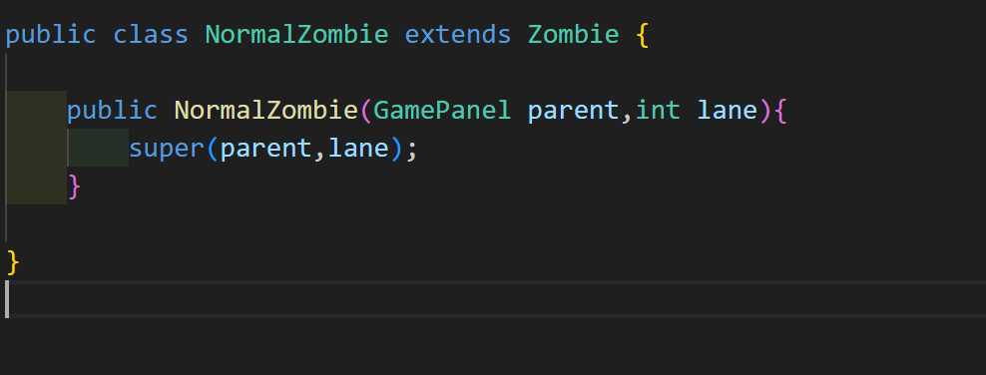

The NormalZombie class extends the Zombie class and represents the default, basic type of zombie.

**Attributes:**

* **health**: Default value of 1000.
* **speed**: Default value of 1.

**Behavior:**

* Inherits all behavior from the Zombie class.
* **No modifications**: The NormalZombie doesn't change any functionality from the base Zombie class. Its primary distinction is the default health and speed values.

**3. ConeHeadZombie (Subclass of Zombie)**

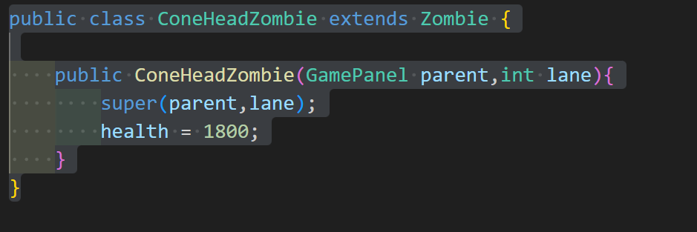

The ConeHeadZombie class extends Zombie and represents a variant of the NormalZombie, with more health.

**Attributes:**

* **health**: Set to 1800, which is higher than the NormalZombie.
* **speed**: Inherited from Zombie (default 1).

**Behavior:**

* Inherits the advance() and slow() methods from the Zombie class.
* **Modified health**: The primary difference is that this zombie has more health, making it harder to defeat than a NormalZombie.
* **No change in speed or movement behavior**: The ConeHeadZombie has the same movement behavior as the NormalZombie. It moves across the screen at the same speed (1).

**Purpose:**

* The ConeHeadZombie is typically used in the game to introduce a zombie that can withstand more damage than the NormalZombie. This can make gameplay more challenging as players must deal more damage to it before it dies.

**4. FootballZombie (Subclass of Zombie)**

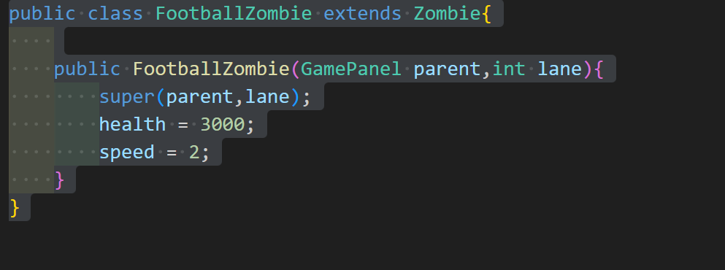

The FootballZombie class extends Zombie and represents a more powerful, faster zombie that is harder to stop.

**Attributes:**

* **health**: Set to 3000, which is much higher than both NormalZombie and ConeHeadZombie.
* **speed**: Set to 2, which makes this zombie move faster than the NormalZombie and ConeHeadZombie.

**Behavior:**

* Inherits the advance() and slow() methods from the Zombie class.
* **Modified health**: This zombie has significantly more health (3000), which means it can take much more damage before dying.
* **Modified speed**: This zombie has a speed of 2, which makes it move faster across the screen than the standard zombies. This means it can potentially reach the player’s plants faster, requiring quicker reactions from the player to deal with it.

**Purpose:**

* The FootballZombie is designed to be a more challenging zombie type, both in terms of damage resistance and speed.
* Players need to be prepared to handle this type of zombie more strategically, using plants with faster firing rates or slowing effects like FreezePea to deal with its increased speed and health.

**Class gamePanel**

1. Class Declaration and Member Variables



* + GamePanel: This class represents the main game panel where all interactions and game logic occur.
  + JLayeredPane: This Swing component allows stacking of components in multiple layers.
  + MouseMotionListener: The class implements this interface to track and handle mouse movement for planting and interaction.

Member Variables

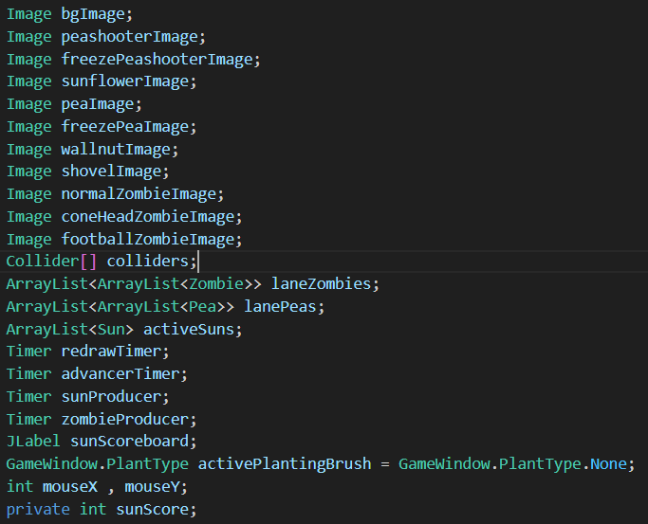

* Images: Store game graphics, including plants, zombies, projectiles, and the background.
* laneZombies and lanePeas: Store zombies and projectiles in separate lists for each lane (5 lanes in total).
* activeSuns: Tracks suns available on the screen for collection.
* Timer objects:
* redrawTimer: Refreshes the screen at regular intervals.
* advancerTimer: Updates game state (movement, shooting) periodically.
* sunProducer: Generates suns at regular intervals.
* zombieProducer: Spawns zombies at fixed intervals.
* sunScore: Represents the total sunlight currency for planting.
* activePlantingBrush: Indicates the currently selected plant type for planting.
* Mouse Coordinates (mouseX, mouseY): Track the mouse position for interactive planting.

1. Constructor

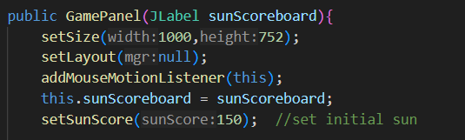

* sunScoreboard: Displays the player's current sun score.
* setSize(1000,752): Sets the size of the GamePanel to 1000 pixels wide and 752 pixels high.
* setLayout(null): Disables the default layout manager for the GamePanel.
* addMouseMotionListener(this): Registers the GamePanel itself as a listener for mouse motion events.
* setSunScore(150): set the initial sun;
* Purpose of constructor: Initializes variables, sets layout, loads images, and creates Colliders for interaction.

Image Loading

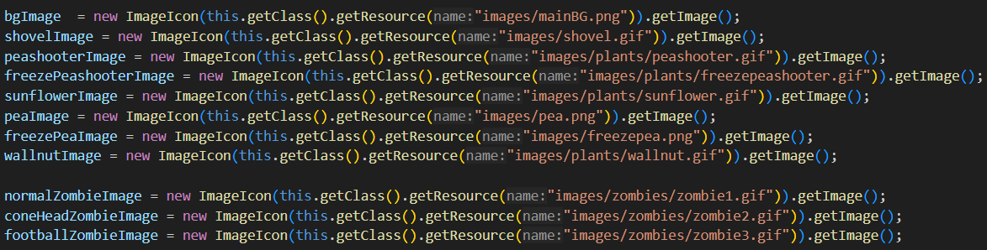

* Loads images for plants, zombies, projectiles, and background from the resource directory.

Collider Setup

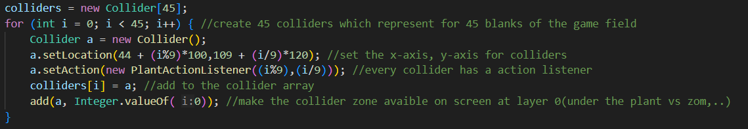

* Creates a 45-slot grid representing the playable area.
* Collider: Tracks plant placement and interaction on specific tiles.

Timers

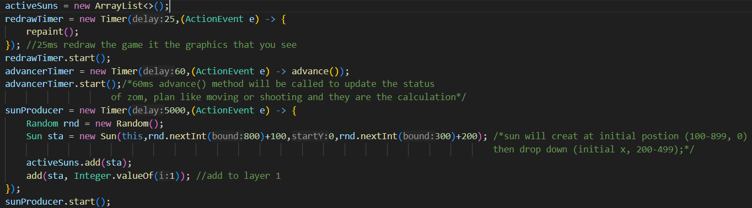

* Redraw Timer (redrawTimer): Refreshes graphics every 25ms using repaint().
* Advancer Timer (advancerTimer): Updates game logic every 60ms (zombies move, plants shoot).
* Sun Producer (sunProducer): Generates falling suns every 5 seconds.

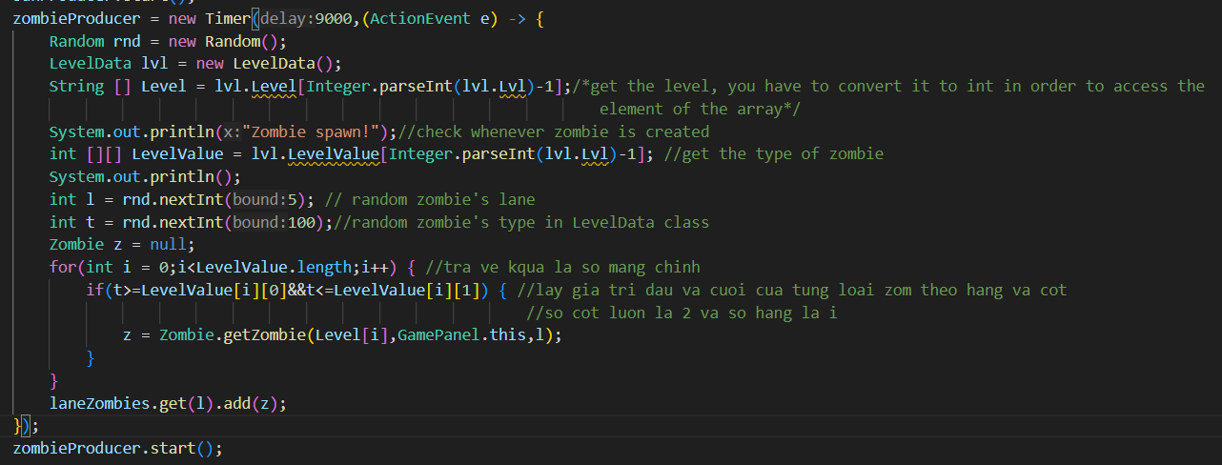

* Zombie Producer (zombieProducer): Spawns zombies randomly across lanes and types every 9 seconds.

1. Core Methods

advance() method

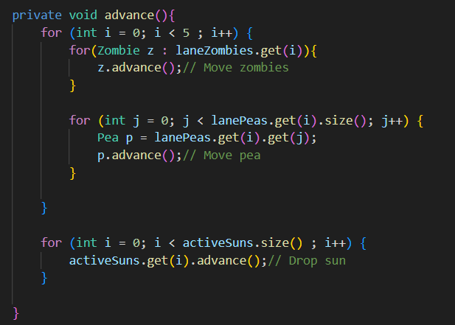

* Updates positions of zombies, peas, and suns.
* Called periodically by advancerTimer.(update every 60ms)

paintComponent(Graphics g)

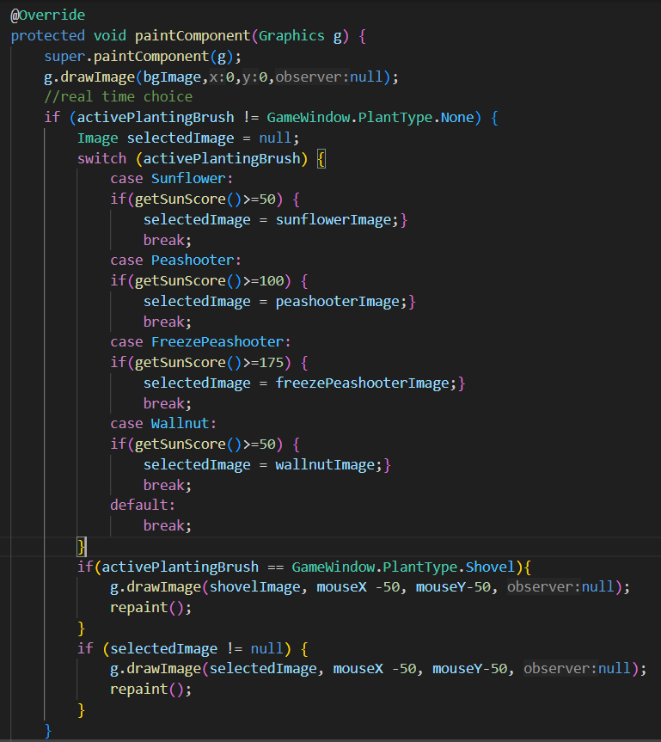

* Draw Background: g.drawImage(bgImage, 0, 0, null);
* Selected Plant or shovel: Shows the selected plant(only when enough sun for Plant that you select) and shovel image under the mouse.

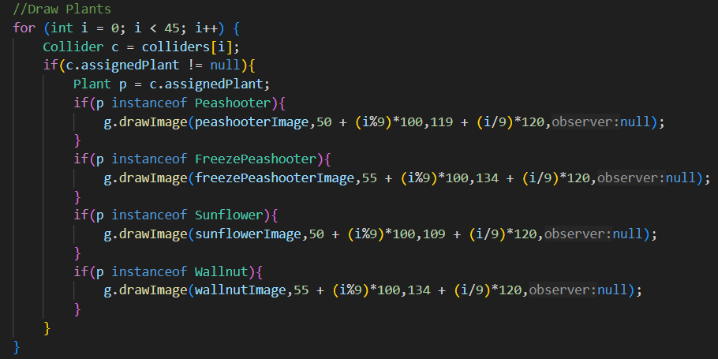

* Plants: Draws plants at their respective grid locations.

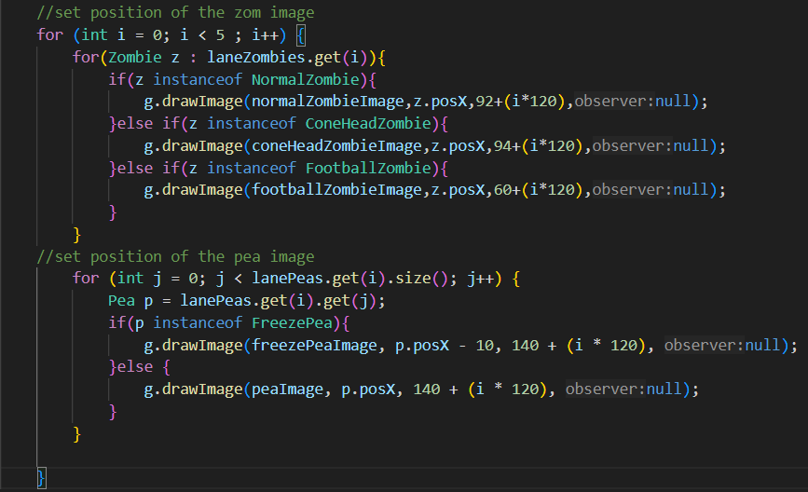

* Zombies: Draws zombies at their current positions.
* Peas: Draws peas as they move along lanes.

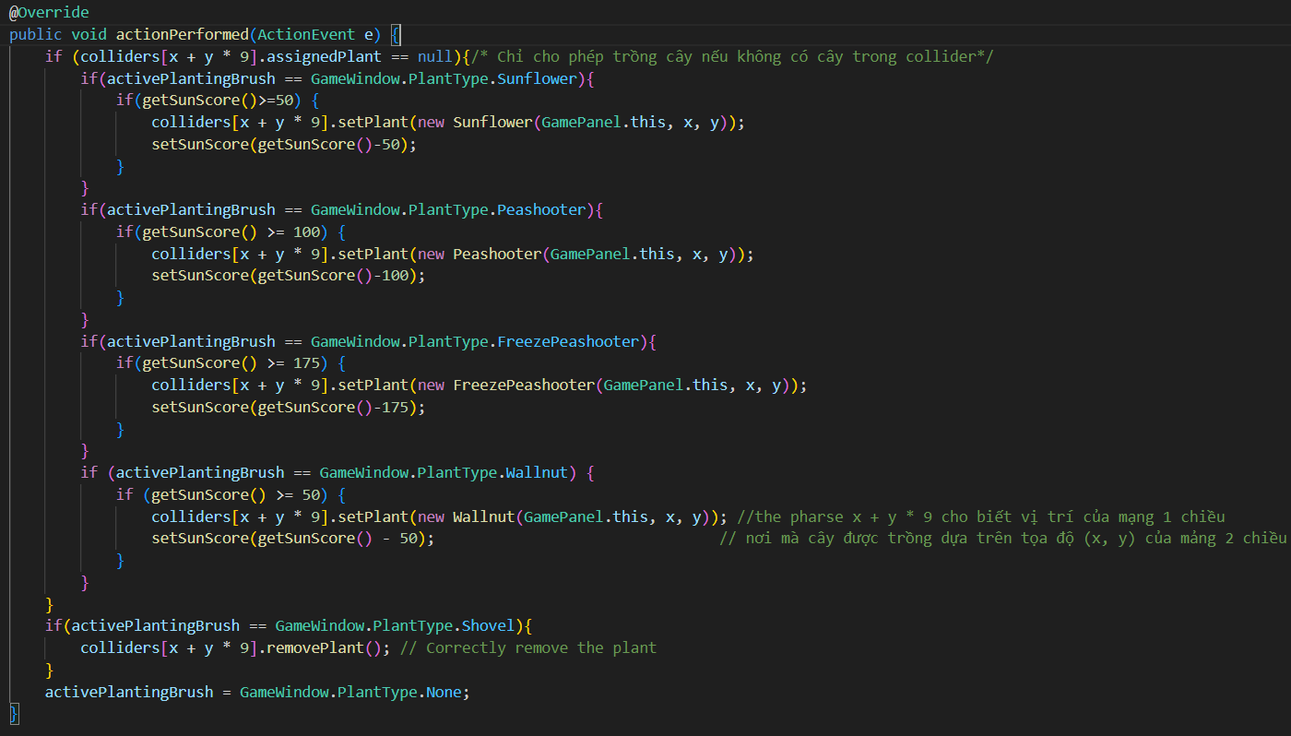

* Handles planting:
* Checks if the grid tile is empty.
* Checks if the player has enough sunlight to plant.
* Plants the selected type and deducts sun score.

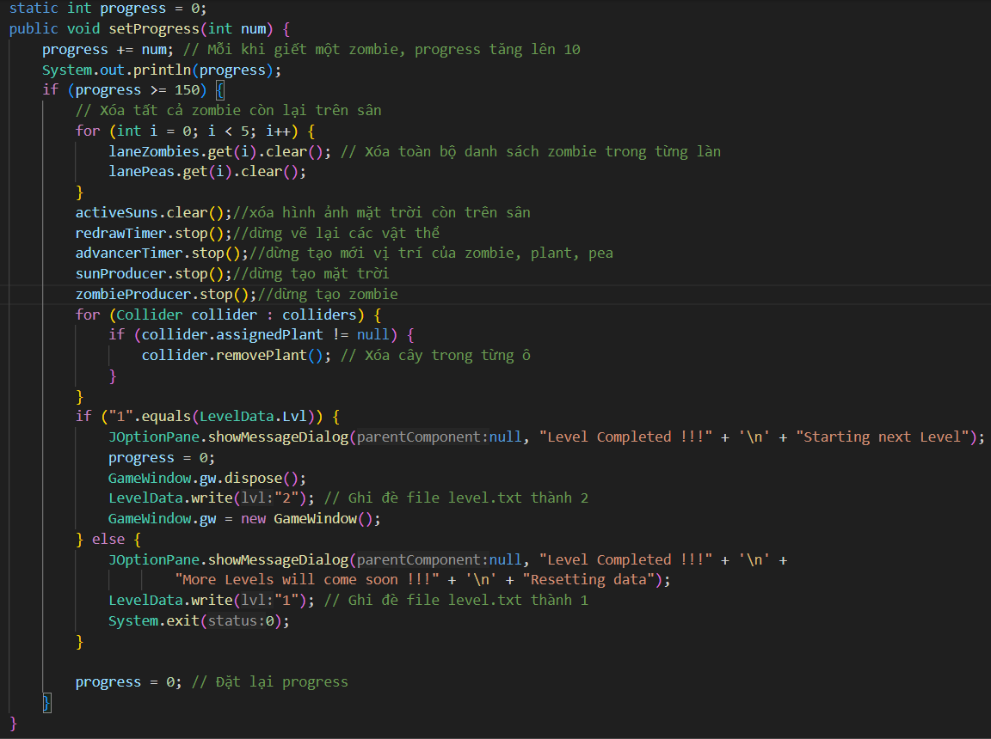

* Tracks progress based on the number of zombies defeated.
* Clears the board and progresses to the next level or resets the game if the level is completed.

1. Mouse Handling

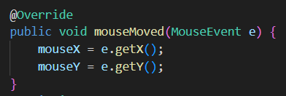

* Updates the mouse coordinates for interactive planting.